System architecture

Gamefederation delivers a software solution that enable games to run at servers on the Internet. The game process is hosted at a server and allows different types of clients to participate in the game (PC and mobile phone).

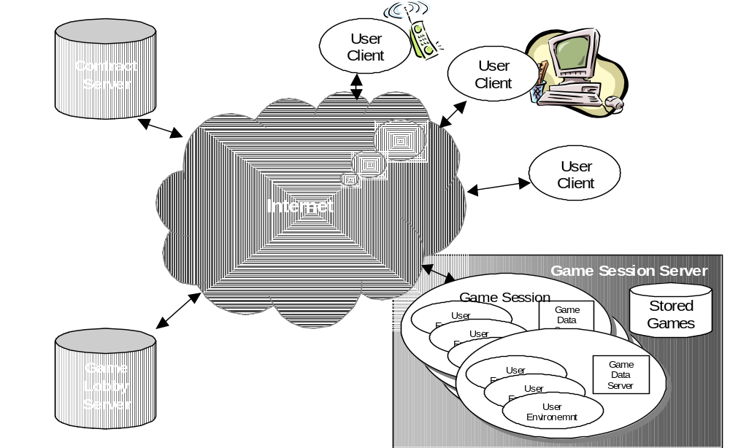

Figure 1. System architecture

Game architecture

The game will consist of one core server component, which acts as the main game process, and a thin client component. Since the client game components are downloaded to the client hardware during game initialisation the client game components should be preferable thin. Therefore the major game process and logic will be hosted at the server.

The solution is a pay for use model where the GF platform provides a pay for time solution. In addition to this the game can send ticks during the game session indicating that player reached certain levels etc. There can also be negative ticks meaning that player won something and get money back.

PC client

High end PC, no restrictions of sound, graphics etc. Windows 95/98/2000.
Java 2 version 1.3.
The game software on PC client will approximately be XX Mbytes (maximum), due a reasonable download time during game initialisation.

Mobile client

Motorola Accompli 008, an unreleased Motorola Java phone (J2ME, KVM). The phone uses the GPRS network.

Limitations on mobile client:

- J2ME (Java 2 micro edition).
- GPRS network, approximately 20 kbps.
- No client IP address, the client needs to do data polling from server.
- HTTP traffic.
- Flash memory (EEPROM) 2 Mbytes available for game.
- RAM: 500 Kbytes available for game, (500 Kbytes used by KVM). ??
- Black and white display, 276 pixels height, 240 pixels width.
- 33 MHz processor.

Test strategy

We provide software that simulates the API:s we requires the game to fulfil.

The development kit from Motorola contains of a simulator of the phone that can be used for test of functionality.

We perform tests in Motorola’s test lab and send feedback back to you. These tests involves:

- Functionality.
- Network performance, lag etc.
- Performance on hardware.
- Stability.

All tests need to be done in Motorola’s lab since only they have the hardware and a test GPRS network.

